UNIT ROOT TESTS WITH PANEL DATA.

Consider the AR1 model

where the . This specification assumes individual specific means with . We know from Nickell (1981) that OLS estimates of (1.1) are biased for fixed T as N goes to infinity. The bias is given by,

where . However, the bias disappears for α=1. The unit root hypothesis can be tested using the t-statistic for H₀: α=1. The t-statistic is distributed asymptotically normal under the null hypothesis of a unit root.

A modified Dickey-Fuller test statistic (Breitung and Meyer, 1994).

Under the alternative hypothesis , the OLS estimate is biased against leading to a loss of power. For a more powerful test, subtract the first observation from both sides of equation (1.1):
.
The OLS estimate of this equation is biased, but the bias disappears under the null hypothesis of a unit root. The advantage of this test equation is that the bias does not depend on the individual fixed effects. This test is generally superior to (1.1).

Hitgher order autocorrelation.

We can generalize the test equation to an AR(p) model. Subtract from both sides and subtract the initial observation from the lagged level to yield the test equation. The linear time trend can be included if the data is trending.

The unit root test consists of testing the null hypothesis in (1.4) which is the panel data equivalent of an augmented Dickey-Fuller test. The t-ratio is distributed normally under the null hypothesis of a unit root. Note that these estimates are done using OLS ignoring the fixed effects.

We can again correct for fixed effects by subtracting the initial observation, from the lagged level.

Again, the appropriate test is the t-test on the null hypothesis, .There are a two small problems with the Breitung and Meyer approach. It assumes that the pattern of serial correlation is identical across individuals, and therefore does not extend to heterogeneous residual distributions. Also, the Breitung and Meyer method is best for panels with a large cross-section and a relatively small time series dimension (T<25).

Wu (1996) suggests the following approach for panels with more than 25 time series observations on each individual. First, subtract off the individual means (demean) and the time means.

Then regress the demeaned series against itself, lagged, with no intercept.

The t-statistic for the null hypothesis of a unit root is defined as follows.

To create the test equation, we subtract from both sides of the equation and add lagged differences to correct for possible serial correlation.
where , so test the null hypothesis that the coefficient on the lagged level is equal to zero. The empirical distributions are found by Monte Carlo simulations calibrated to the sample. For a panel of N individuals and T time series observations, generate N independent random walks with T observations each. The resulting series are demeaned as in (1.5) above. The test statistic is found by estimating (1.6) with the transformed data. Repeating this process 10,000 times generates the 5% significance levels. Use the usual standard errors and t-ratios.

The Wu technique is derived from Levin and Lin (1992) According to Levin and Lin, if the error terms in a panel are independent and identically distributed (i.i.d.) and there are no fixed effects, then the panel regression unit root t-statistic converges to the standard normal distribution. However, if individual fixed effects are present, or there is serial correlation in the residuals, the test statistic converges to a non-central normal distribution that requires either a correction to the t-statistic or revised tables of critical values.

The appropriate tables of critical values for data with fixed effects are given in Levin and Lin (1992) and reproduced as Table 5 below (p.8).

One of the important results of the panel data analysis of unit root tests is the discovery that the addition of a few individuals to a panel dramatically increases the power of the unit root tests over such tests applied to single time series. The increase in power comes from the additional variance (information) provided by independent cross-section observations.

The major problem with both the Breitung-Meyer and Levin-Lin approach is the assumed alternative hypothesis. The null hypothesis, which we can all agree on, is that Under the alternative hypothesis, . While it is perfectly sensible to reject the null that all the individuals have unit roots, it is unreasonable to assume that they all have the same degree of stationarity. If we are talking about purchasing power parity, it is sensible to test the null hypothesis that none of the countries converge to parity (i.e., they all have unit roots). It is less reasonable to assume that they all converge to parity at the same rate.

Im, Pesaran, and Shin (IPS) relax the alternative that . They estimate the following ADF test equation for each individual.

The test for a unit root consists of testing the coefficient on the lagged level with a t-test. To test the null of a unit root across all individuals, merely take the average of the t-ratios ("t-bar test").
where is the t-ratio for the individual i using all T time series observations. IPS also propose an "LM-bar" test where they compute an average Lagrange multiplier test of the null hypothesis that the lagged level has no explanatory power (its coefficient is zero so that , for all i) across all individuals. The Monte Carlo results indicate that the t-bar test is somewhat more powerful.

When the errors are serially uncorrelated and independently and normally distributed across individuals, the resulting "LM-bar" and "t-bar" test statistics are distributed as standard normal for large N (number of individuals) and finite T (number of time periods). When the errors are serially correlated and heterogeneous across individuals, the test statistics are valid as T and N go to infinity, as long as N/T goes to k where k is some finite positive constant. The tests are consistent under the alternative hypothesis that the fraction of the individual processes that are stationary is non-zero. Monte Carlo results show that these tests outperform the Levin and Lin test in finite samples.

If there are unobserved time-specific common components (significant year dummies), the disturbances are correlated across individuals. The t-bar test requires that the errors be independent and therefore breaks down. To remove the common time series component, demean the data by subtracting the cross section mean, from the original series before applying the ADF test for each individual. Note that there will be one cross section mean for each year, t. Thus, the test equation is

where . The only remaining difficulty is that the data are trending according to a deterministic time trend and the coefficient on the trend is different across individuals. This, according to IPS, requires further research.

Nevertheless, again, note how useful it is to have several cross section observations of a set of time series. Even if the panels are heterogeneous, we can use the independence of the cross sections to generate independent t-tests, which are then averaged. The averaging generates a substantial increase in power over the usual single time series unit root test.

So, the bottom line is that the IPS approach is superior to the others. Tables of critical values for the t-bar test are reproduced below. A sample SAS program is available to be downloaded from http://faculty.wm.edu/cemood/panelur.sas.

One might wonder what is gained from the knowledge that your panel data contain unit roots. What is an econometrician to do if the data have unit roots. What does one do if the panels are stationary? It turns out that it doesn't really matter very much.

PANEL REGRESSION MODELS WITH NONSTATIONARY DATA.

The obvious question is, “So what if the data show unit roots?” Clearly, if the data are stationary, then the usual Gauss-Markov assumptions hold and there is nothing new. If the unit root tests do not reject the null hypothesis of a unit root, what do we do? It turns out that the usual pooled time series and cross section regression models yield useful information concerning the long run regression relationship (Phillips and Moon, 1999).

Suppose we have two I(1) vectors, Yit and Xit. When there is no cointegrating vector linking the two vectors, a time series regression of Yit on Xit for any i, is spurious. Now suppose we have panel data with a large number of individuals. In this case, even if the noise in the time series regression is strong, the noise is usually independent across individuals. So, by pooling, we can reduce the effect of the residuals (noise) and keep the signal. The result is a consistent estimate of a long-run regression coefficient. The estimated coefficient is an estimate of the long run average relationship over the cross sections. Cross sections are typically thought to reflect the long run relationship.

Note that Pesaran and Smith (1995) have shown that the long run relation can be consistently estimated from a set of randomly different cointegrating coefficients. They recommend using a cross-section regression on time-averaged data. However, compared to the pooled panel estimator, this limiting cross section estimator is inefficient.

The bottom line (Phillips and Moon, 1999, p. 1058) is that there are four possible panel structures for nonstationary data: (1) no cointegrating relation, (2) heterogeneous cointegrating vectors, (3) a homogeneous cointegrating vector, (4) near-homogeneous relations. In all four cases, the pooled panel estimator yields consistent estimates with a normal limit distribution. This means that it doesn’t matter whether the panel data have unit roots. In any case we are estimating a meaningful regression with the usual standard errors and t-ratios.

Note that while the regression is a meaningful long run relationship, if there is a possibility of reverse causation (simultaneity), the long run regression cannot distinguish causal direction. Also, when estimating long run average relationships, do not include lagged dependent variables on the right hand side. To do so, would imply a short run relationship.

These results hold in the presence of individual fixed (or random) effects (Phillips and Moon, 1999, pp. 1088-1091). The only difference is that you use demeaned data. If the independent variables also have individual deterministic trends as well as stochastic trends, then use detrended data rather than demeaned data.

Statistical tests are done using asymptotic distributions. For example, suppose we want to test the hypothesis that the coefficients for OECD countries (=a) are different from developing countries (=b). That is, test H0 βa = βb in the model

where and . Use the Wald test (asymptotic F-test) against a chi-square distribution. {Use the Test statement in either SAS or Stata.}

In summary, suppose we have a panel data set with relatively large N and T. There exists interesting long run relationships between two integrated panel vectors even where there is no individual time series cointegration or where the cointegration is heterogeneous (likely). These interesting relations are long run average cross-section relationships (i.e., averaged over the time periods). This makes sense in that the cross section is usually assumed to reflect the long run equilibrium relationship. They are analogous to the population (not sample) regression coefficients in conventional cross section regressions.

These results require cross section independence. Some weak results can be derived in the presence of dependence, but it is a function of the particular case at hand. If the individuals cannot be assumed to be independent, then the procedure falls apart.

So, if there is no simultaneity and we are primarily interested in the long run relationship, it doesn't matter much whether the data have unit roots or not. If they do then the usual fixed effects model is the long run average relationship. If they are stationary, then the pooled model (in levels) is again the long run relationship.
References.

Breitung, Jorg and Wolfgang Meyer, Testing for unit roots in panel data: are wages on different bargaining levels cointegrated? Applied Economics, 1994, 26, 353-361.

Im, K.S., M.H. Pesaran, and Y.Shin. Testing for unit roots in heterogeneous panels. Working paper, University of Cambridge, December 1997.
Text: http://www.econ.cam.ac.uk/faculty/pesaran/lm.pdf.
Tables: http://www.econ.cam.ac.uk/faculty/pesaran/lmtab.pdf

Levin, Andrew and Chien-Fu Lin, Unit root tests in panel data: asymptotic and finite-sample properties. Department of Economics UCSD Discussion Paper 92-23, May 1992.

Nickell, S. Biases in dynamic models with fixed effects. Econometrica, 1981, 49, 1417-26.

Pesaran, H. and R. Smith, Estimating long-run relationships from dynamic heterogeneous panels, Journal of Econometrics, 1995, 68, 79-113.

Phillips P.C.B. and H.R. Moon, Linear regression limit theory for nonstationary panel data. Econometrica, 1999, 67, 1057-1111.

Wu, Yangru, Are real exchange rates nonstationary? Evidence from a panel-data test. Journal of Money, Credit, and Banking, 1996, 28, 56-63.

Critical Values for Levin-Lin Unit Root Test

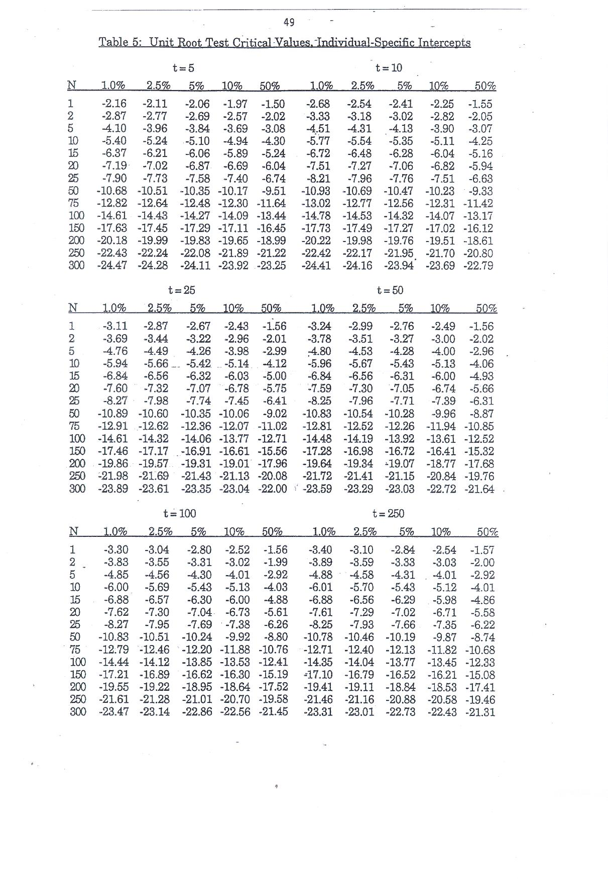

Critical Values for Im, Pesaran, and Shin t-bar Unit Root Test
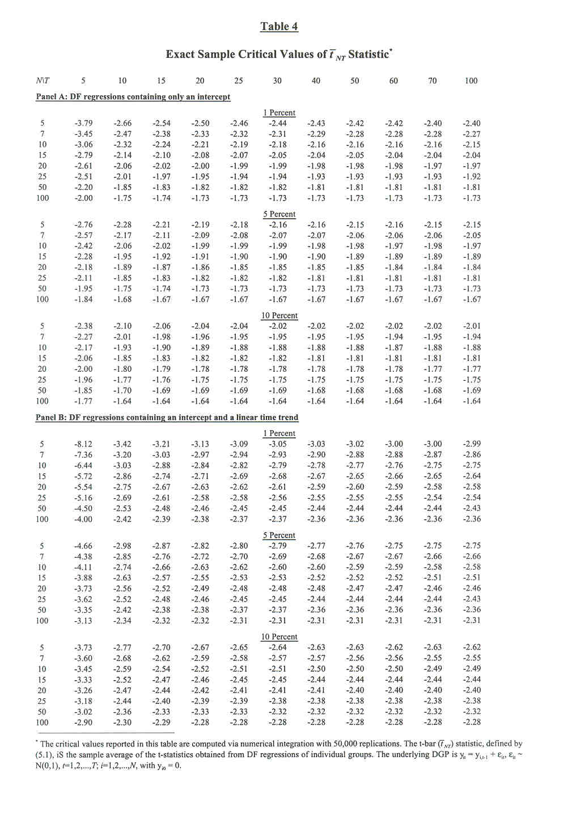
Critical Values for Im, Pesaran, and Shin LM-bar Unit Root Test
